BLINKIT ANALYSIS
To see all imported data :
select * from blinkit_data;
Data Cleaning :
UPDATE blinkit_data
SET Item_Fat_Content =
case when Item_Fat_Content in ('LF','low fat') then 'Low Fat'
when Item_Fat_Content = 'reg' then 'Regular'
else Item_Fat_Content
end;
After executing this query check the data has been cleaned or not using below query:
select distinct(Item_Fat_Content) from blinkit_data;]\
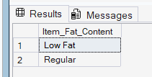

KPI’s :
- TOTAL SALES :
select round(sum(Sales)/1000000,2) as Total_Sales_millions from blinkit_data;
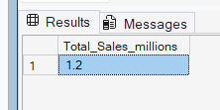

- AVERAGE SALES :
select round(avg(Sales),1) as Average_Sales from blinkit_data;
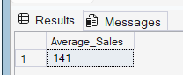

- NUMBER OF ITEMS SOLD :

select count(*) as total_items_sold from blinkit_data;
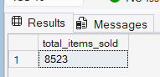

- AVERAGE RATING :

select round(AVG(Rating),2) as average_rating from blinkit_data;
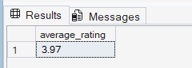

GRANULAR REQUIREMENTS :

- Total Sales, Avg Sales, Total Item Sold, Avg Rating By FAT CONTENT :

select Item_Fat_Content,
round(sum(Sales),2) as Total_Sales,
round(avg(Sales),1) as Average_Sales,
count(*) as total_items_sold,
round(AVG(Rating),2) as average_rating
from blinkit_data
group by Item_Fat_Content
order by Total_Sales desc;

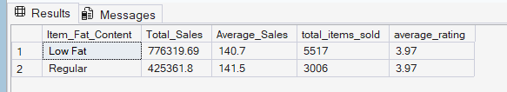

- Total Sales, Avg Sales, Total Item Sold, Avg Rating By Item Type:

select Item_Type,
round(sum(Sales),2) as Total_Sales,
round(avg(Sales),1) as Average_Sales,
count(*) as total_items_sold,
round(AVG(Rating),2) as average_rating
from blinkit_data
group by Item_Type
order by Total_Sales desc;

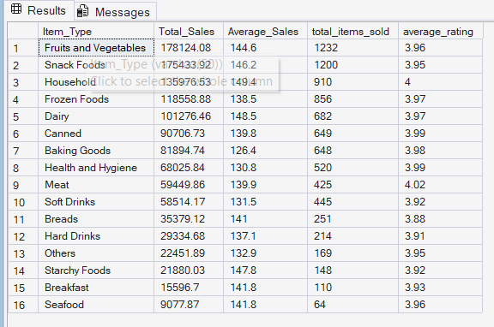

- Fat Content by Outlet Location Type for Total Sales :

select Outlet_Location_Type,isnull([Low Fat],0) as Low_Fat,isnull([Regular],0) as Regular
from
(
select Outlet_Location_Type, Item_Fat_Content,round(sum(Sales),2) as total_sales from blinkit_data group by Outlet_Location_Type,Item_Fat_Content
) as SourceTable
pivot
(
sum(total_sales) for Item_Fat_Content in ([Low Fat],[Regular])
) as PivotTable
order by Outlet_Location_Type;

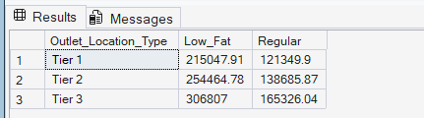

- Total Sales, Avg Sales, Total Item Sold, Avg Rating By Outlet Establishment Year :

select Outlet_Establishment_Year,
round(sum(Sales),2) as total_sales,
round(avg(Sales),1) as Average_Sales,
count(*) as total_items_sold,
round(AVG(Rating),2) as average_rating
from blinkit_data
group by Outlet_Establishment_Year
order by Outlet_Establishment_Year asc;

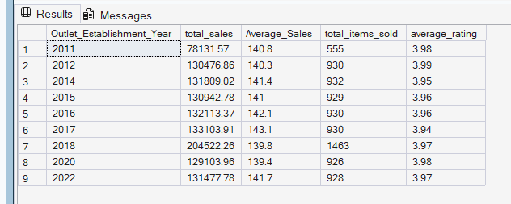

- Percentage of sales By Outlet Size :

SELECT
Outlet_Size,
ROUND(SUM(Sales), 2) AS total_sales,
ROUND(SUM(Sales) * 100.0 / SUM(SUM(Sales)) OVER(), 2) AS Percentage_Sales
FROM
blinkit_data
GROUP BY
Outlet_Size
ORDER BY
total_sales DESC;

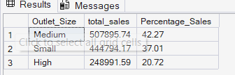

- Total Sales, Avg Sales, Total Item Sold, Avg Rating By Outlet Location Type :

select Outlet_Location_Type,
round(sum(Sales),2) as total_sales,
round(avg(Sales),1) as Average_Sales,
count(*) as total_items_sold,
round(AVG(Rating),2) as average_rating
from blinkit_data
group by Outlet_Location_Type
order by total_sales desc;

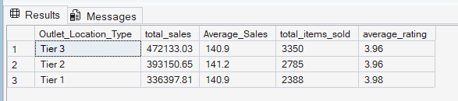

- All Metrics By Outlet Type :

select Outlet_Type,
round(sum(Sales),2) as total_sales,
round(sum(Sales)*100.0/sum(sum(Sales))over(),2) as sales_percentage,
round(avg(Sales),1) as Average_Sales,
count(*) as total_items_sold,
round(AVG(Rating),2) as average_rating
from blinkit_data
group by Outlet_Type
order by total_sales desc;

